Auto ai –experiment-deployed link:

<https://us-south.ml.cloud.ibm.com/ml/v4/deployments/ec87e25f-4b44-4451-9ad6-8138f76e51dd/predictions?version=2020-10-19>

Architecture Diagram

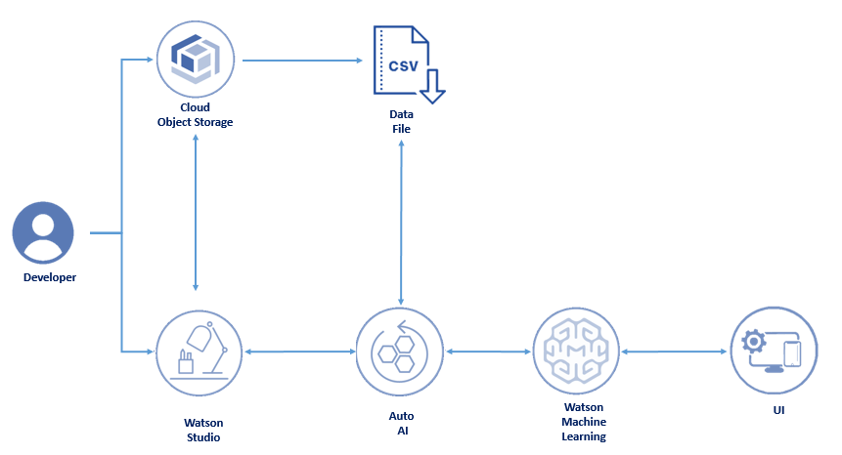

1. Logged into Watson Studio, creates a project named it as ‘insurance project ’ and initiates an instance of Auto AI & Object Storage.

2. Uploaded the data file in the CSV format to the object storage.

3. User initiates the model building process using Auto AI and create pipelines.

4. User evaluates different pipelines from Auto AI and selects the best model for deployment.

5. User generates accurate predictions by making ReST call to the deployed model

**Included components**

* [IBM Watson Studio](https://www.ibm.com/cloud/watson-studio): Analyze data using RStudio, Jupyter, and Python in a configured, collaborative environment that includes IBM value-adds, such as managed Spark.
* [IBM Auto AI](https://dataplatform.cloud.ibm.com/docs/content/wsj/analyze-data/autoai-overview.html):The AutoAI graphical tool in Watson Studio automatically analyzes your data and generates candidate model pipelines customized for your predictive modeling problem.
* [IBM Cloud Object Storage](https://console.bluemix.net/catalog/services/cloud-object-storage): An IBM Cloud service that provides an unstructured cloud data store to build and deliver cost effective apps and services with high reliability and fast speed to market. This code pattern uses Cloud Object Storage.

# teps using AutoAI

Follow these steps to setup and run this code pattern using Auto AI.

1. Create an account with IBM Cloud
2. Create a new Watson Studio project
3. Add Data
4. Add Asset as Auto AI
5. Create and define experiment
6. Import the csv file
7. Choose predict column , configure experimental settings
8. Run experiment
9. Analyze results
10. Deploy to Cloud
11. Model testing

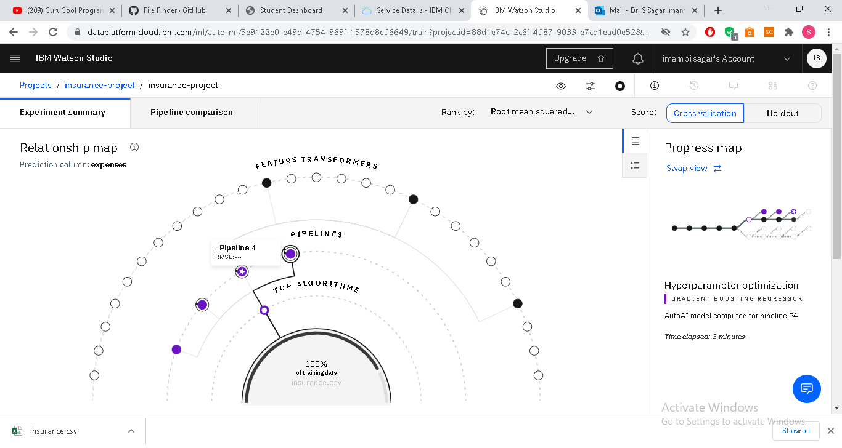

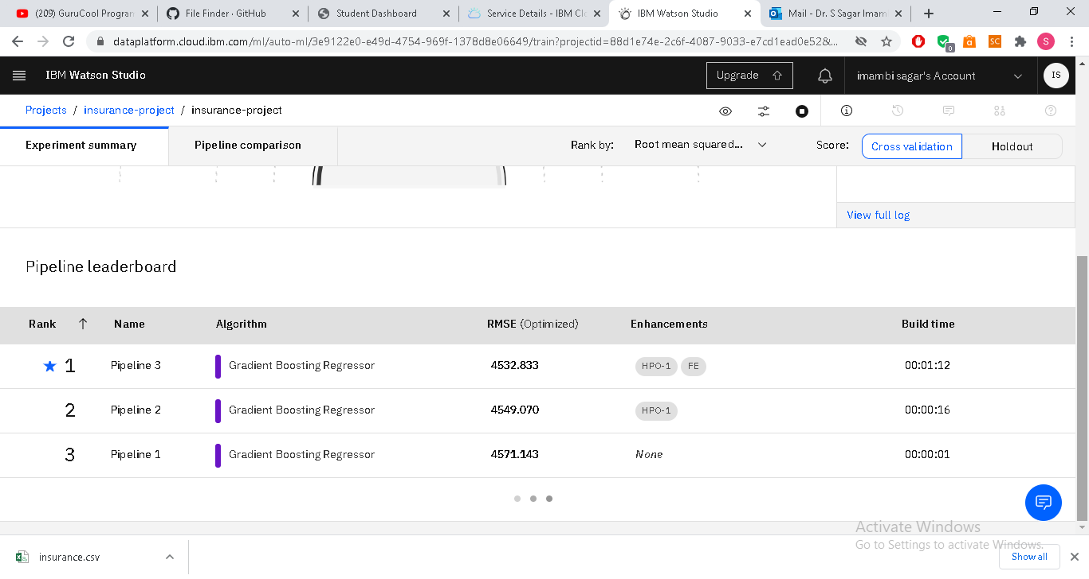

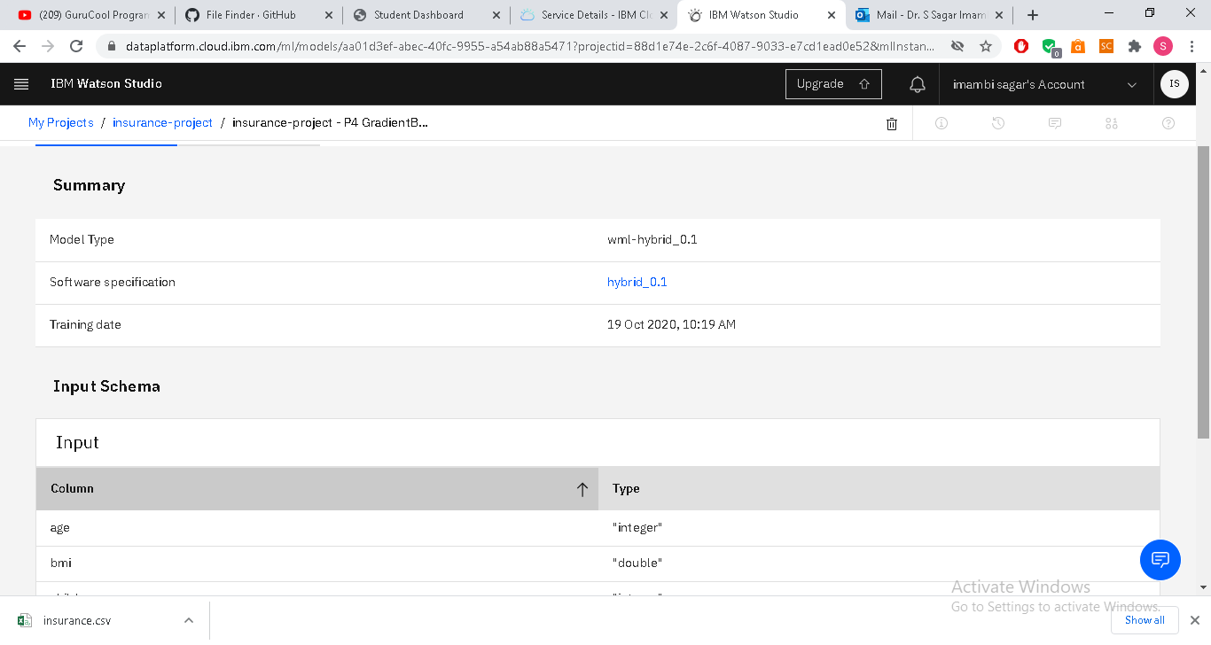

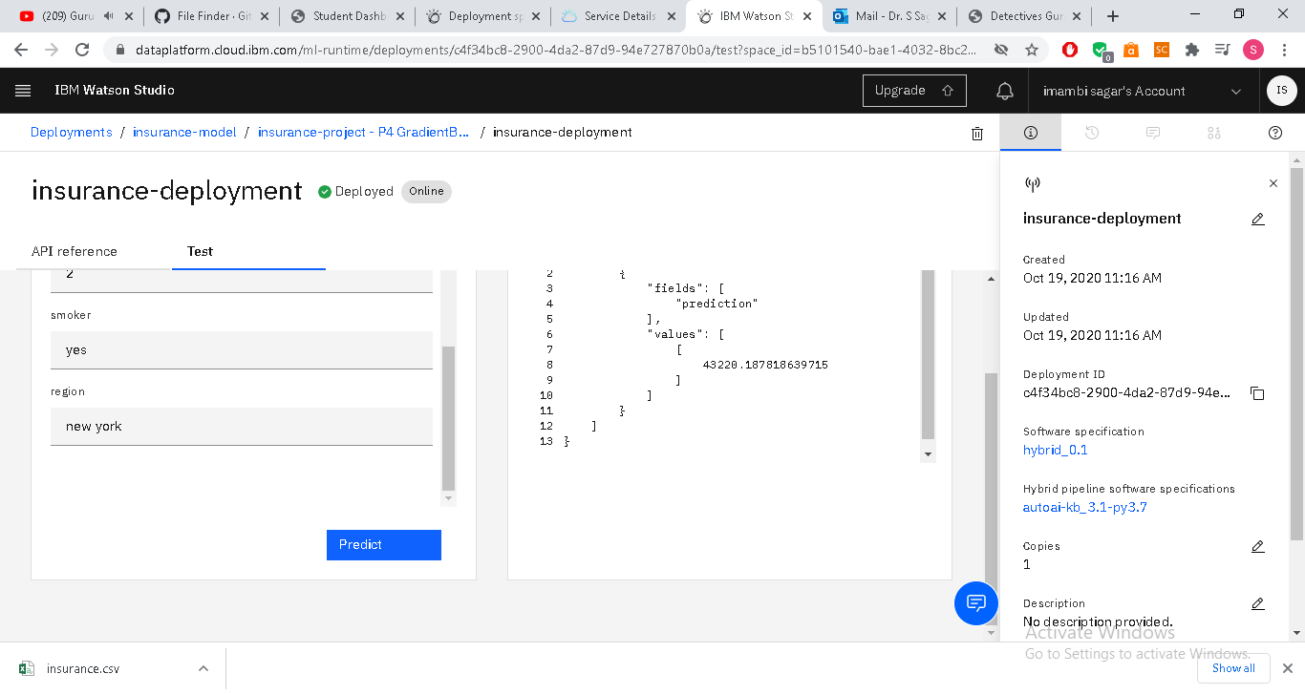

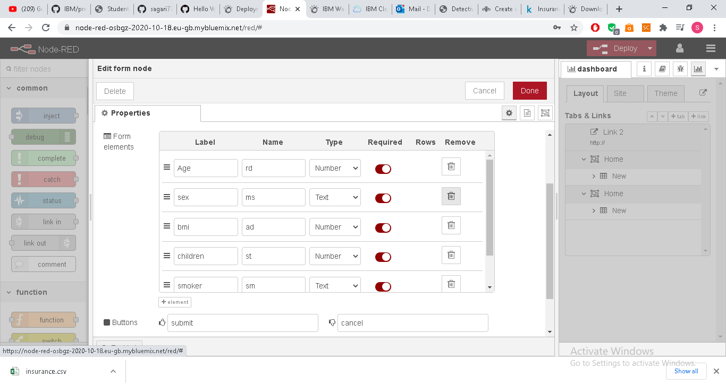

rg

999ff4cb095d8b09d2e98100288c16f4f53a1a80  github token

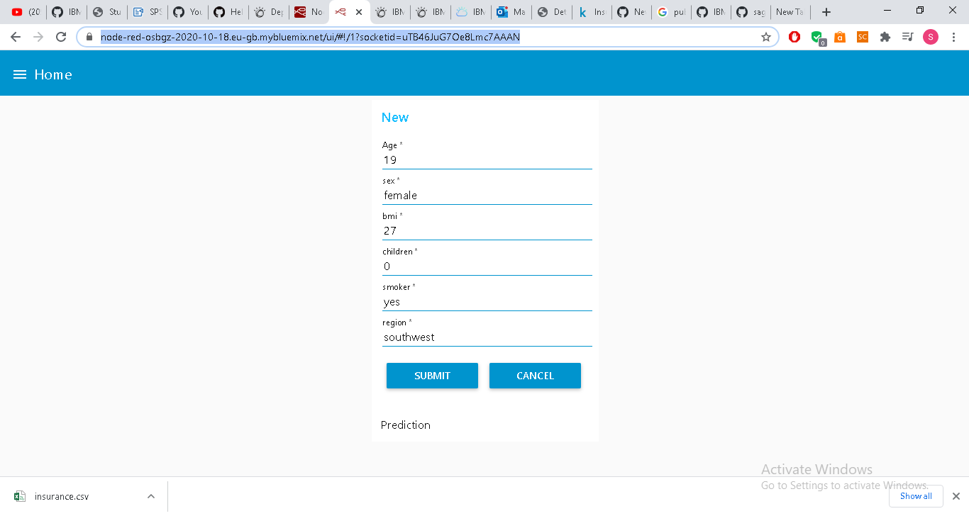

https://node-red-osbgz-2020-10-18.eu-gb.mybluemix.net/ui/#!/1?socketid=uTB46JuG7Oe8Lmc7AAAN